Step-1: ubuntu a fresh ubuntu image form docker library.

**Command:** # docker pull ubuntu

**Status:**

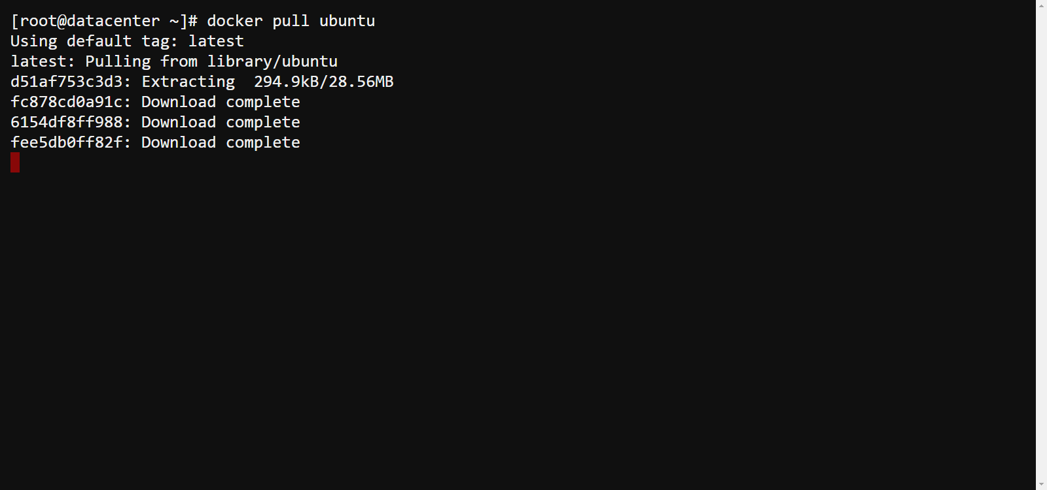

Step-2: Start a container.

**Command:** # docker container run -it ubuntu /bin/bash

**Status:**

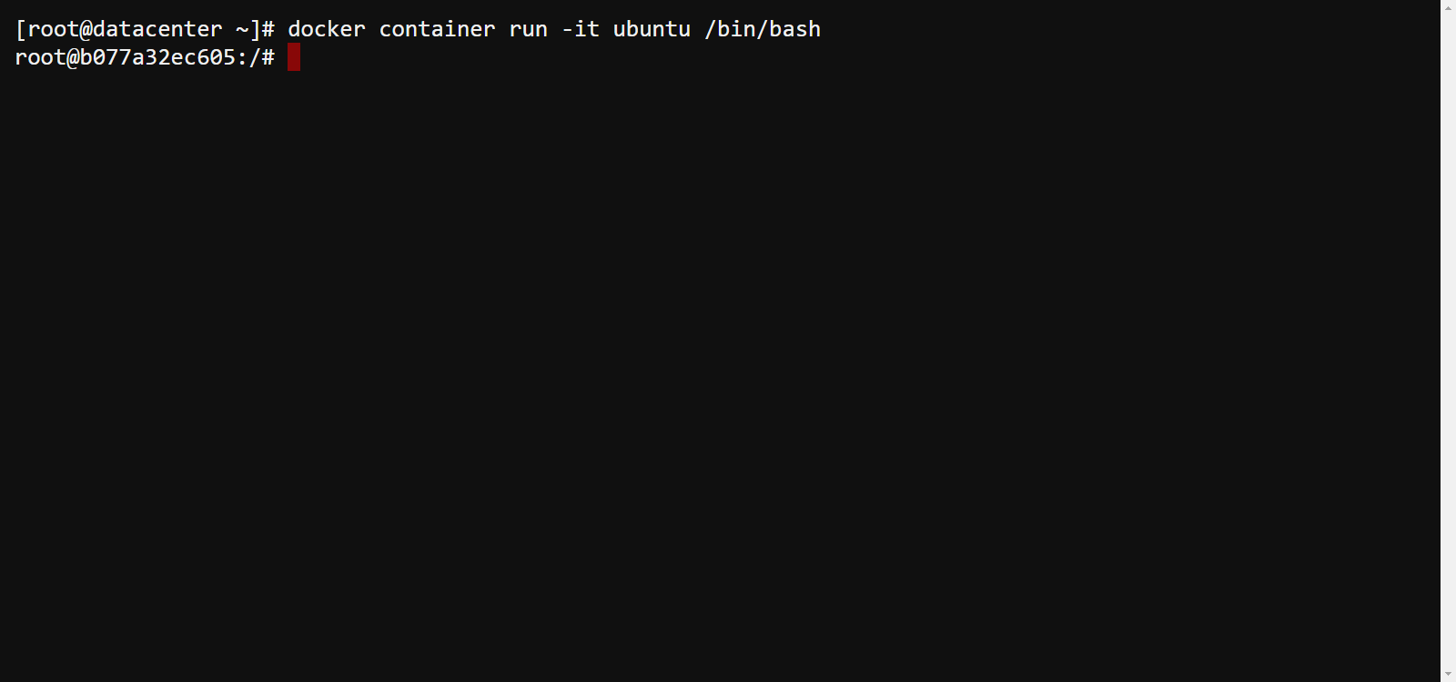

Step-3: List a container status.

**Command:** # docker container ls

# docker container ls -a

**Status:**

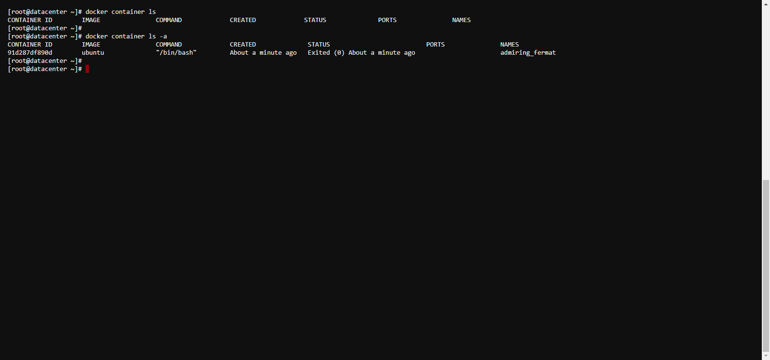

Step-4: Star a stop container.

**Command:** # docker container start container_id

**Status:**

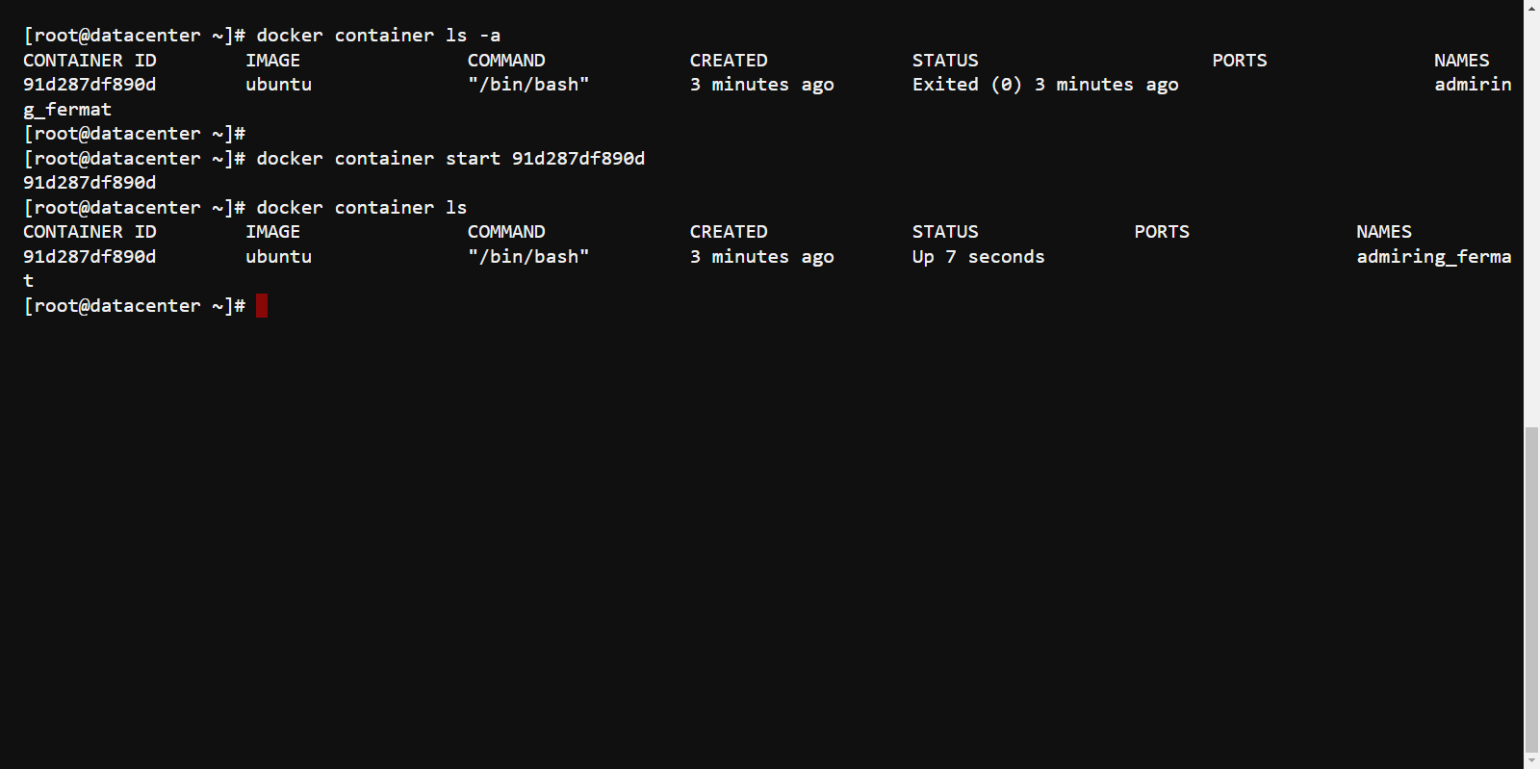

Step-5: Also, you can use “exec” command to container shell.

**Command:** # docker container exec -it container_id bash

**Status:**

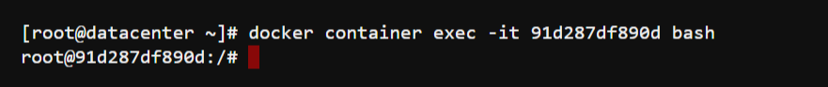

Step-6: stop the running container.

**Command:** # docker container stop container_id

**Status:**

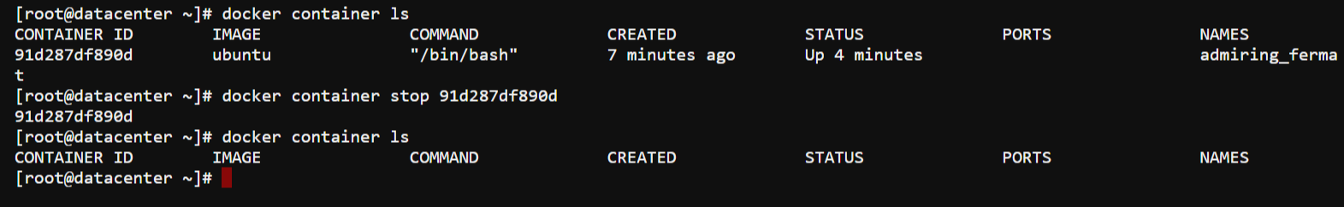

Step-7: Also, you can use “exec” command to container shell.

**Command:** # docker container exec -it container_id bash

**Status:**

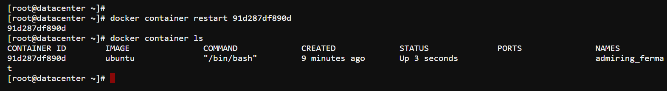

Step-8: Also, you can use “kill” command to terminate container.

**Command:** # docker container kill container_id

**Status:**

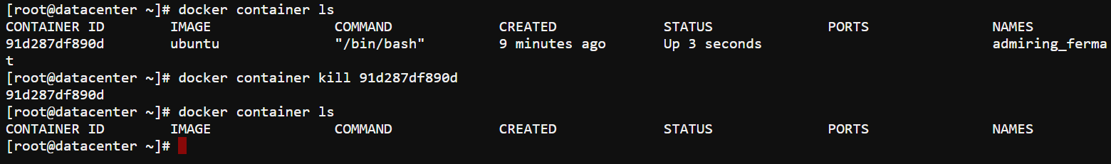

Step-9: Start a container application named nginx in background.

**Command:** # docker container run -itd nginx

**Status:**

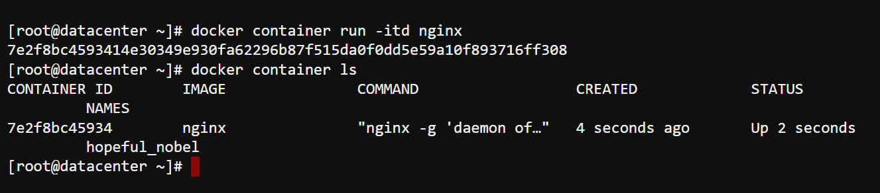

Step-10: Use base machine Firefox to check out the website.

**Command: $ firefox http://172.17.0.2**

**Status:**

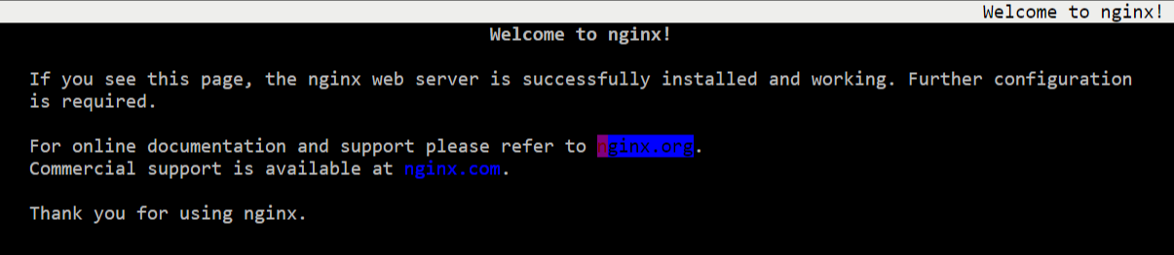

Step-11: Brought to the foreground container.

**Command: # docker container wait container_id**

**Status:**

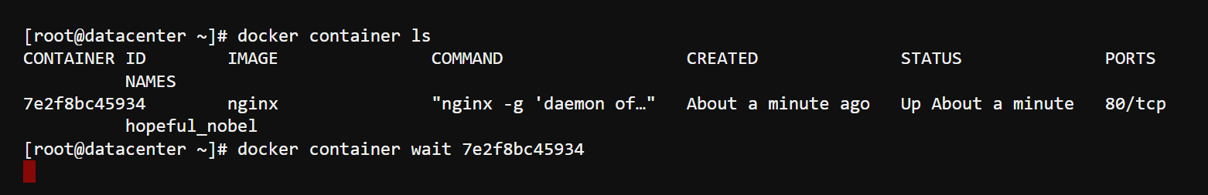

Step-12: start a nginx web server with specific port.

**Command: # docker container run -itd nginx -p 3838:80**

**Status:** 

Step-12: Use remote machine Chrome to check out the website.

**Command: chrome: http://192.168.121.153:3838**

**Status:**

